Bilal Shatila

Game Engines: Game Changers

For the: **Technology: The Evolution of Play**

Ever since technology has merged with gaming, the world continues to see the rapid evolution and improvement of video games decade after decade. We have come so far from any expectations with how the new technology is shaping the video games that we play and experience every day. One of the biggest game-changer elements that benefitted from new technologies is the game engines. In this essay, I talk about how game engines drastically improved gaming to the way we see it today.

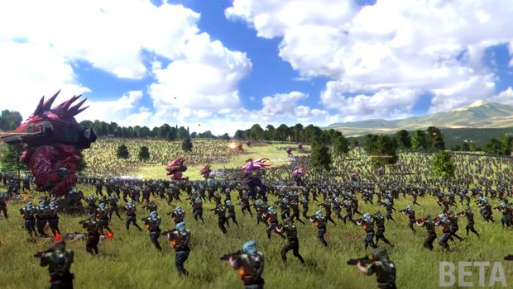

A game engine is a software development program that allows game developers to build and design video games for console, mobile, or PCs. Back in the 90s, first-person shooter games, like Doom, were dominating the gaming scene and arousing the attention of most all players. Doom is a first-person shooter game that contains a lot of gore and violence in it -- it is a 2D game where players can only turn left and right and stumble against 2-3 enemies on their screen to fight them. At that time, a team of 6 Croatian people was thoroughly interested in playing and developing video games, so they planned on developing a new game engine that would meet their development capabilities. They wanted the players to see up to 100 enemies/NPCs (Non-playable characters) on the screen without causing the PC to crash due to all the animations going on; that has never been done before by any huge game companies at that time. So, this team built the Serious Engine  game engine that ran the Serious Sam video game, which is based-off Doom, Duke Nukem, Quake, and a lot of first-person shooter games. The game could run on old and weak PCs, which is quite interesting considering the number of NPCs that the game would render in front of you. It was the kick-starter for how game developers could benefit from and improve the game engines -- this allowed big games to fully-render numerous animations playing at once while not burning and overheating the device you are playing on. Today, Serious Sam continues to be one of the biggest games that utilize the inclusion of countless numbers of enemies rendering all at once, thanks to the new Serious Engine 4 game engine. The game is reportedly said to show over 100,000 enemies on one screen which is a crazy number to think of.



Moreover, fast-forward to today’s generation, technology is continuously and massively contributing to help shape video games in a fantastic way that has never been seen before. The image above is taken from a video Demo, released by Unreal Engine, showcasing the next-gen real-time graphics that the gaming world will see in the upcoming years. Unreal Engine is a game engine developed by Epic Games, and it is one of the most popular and leading engines in the gaming industry nowadays. This video focuses on three main systems that explain, in detail, how games like this one utilized improvised technology. The first system is called Lumen, which is responsible for the dynamic global lightning. Usually, in video games, game designers use custom textures on their games to lighten or darken the surfaces the way they like, however, this technology depends only on one source which is the sun rays and lightning coming from the sun in the game. This other new system helps global lightning to bounce off the surfaces naturally when the sun rays hit them, it is called the Nanite. Rather than rebuilding and re-texturing every object found in the game, developers can now capture real-life textures of dirt, rocks, sand… and place them in-game, and allow the new game engine to restructure them using tiny triangles. Every object we see in-game and on our screens is made of tiny and numerous squares or triangles that would help shape them into the way we see them. These reportedly billions of tiny triangles found in the game interact naturally with the sunbeam coming directly towards them and bounce them off to other surfaces. These tiny bits that you see in the image below are the tiny triangles that shape the textures of the game -- they almost look like pixels. This image is also taken from the game that was showcased in the Unreal Engine 5 video.

Additionally, the Niagara system allows for dynamic and smooth interactions between the character you are playing with and the environment around him, as well as between the NPCs and nature. Let’s say your character is going through a narrow opening of a huge rock, and some dirt fell on him -- the character would interact and clean the dirt off him. All these new systems and technologies help build photorealistic video games, and photorealism is an art that is indistinguishable from reality.

Speaking of new advancements in technologies, loading screens have always been so annoying to sit and stare at, not to mention the same tips and tricks that always rotate while the game is loading. With the introduction of the new PlayStation 5 console from Sony, games load up so quickly in a way that has never been seen before, thanks to the new insanely fast custom SSD (Solid State Drive) that was built by Sony. Marvel's Spider-Man: Miles Morales was one of the very few games that were made to be fully optimized on the PS5 on day one. From the time you press ‘Launch Game’ to the time you get to the main menu screen, there are only 10 seconds of waiting. Ten seconds to load a full game that has the latest technological systems and top-notch graphics is crazy to think of.

In brief, it is amazingly cool to see how seamless, dynamic, and realistic video games are becoming in the past few years. It is as if we are leaping at a fast pace in technology and utilizing its true hidden capabilities by merging it with the beautiful world of games. Game developers never fail to amaze their audiences with the consistent improvement of the game engines, which open new horizons for players to explore and experience the games they play on a whole new realistic-like level. I cannot wait to see what the future of gaming holds for us!

References for the images used in this essay:  
[Share your excitement for Unreal Engine 5 with free wallpapers, GIFs, and more! - Unreal Engine Forums](https://forums.unrealengine.com/unreal-engine/announcements-and-releases/1760020-share-your-excitement-for-unreal-engine-5-with-free-wallpapers-gifs-and-more)  
  
[Serious Sam 4's brutal carnage at mass scale is thanks to Serious Engine (altchar.com)](https://www.altchar.com/game-news/serious-sam-4s-brutal-carnage-at-mass-scale-is-thanks-to-serious-engine-a8ELp4o1ZkuV)